**Procedure for rocket_tracker_gui.m**

The rocket_tracker_gui is a MATLAB interface that can be used to save the x- and y-positions of a water bottle rocket over the course of a launch.

**Set-up Procedure:**

1. Convert video of your experiment to a MATLAB-readable format (i.e. MP4).

After transfering your video file from the camcorder to a computer, it must be converted from a .MTS file to a .MP4 video. This can be done with the free VLC media player available here: <http://www.videolan.org/vlc/index.html> . This software is also already installed on the ITLL computers. Follow this tutorial to see how to convert the file.

Open your file with VLC media player and press Ctrl+R or go to Media🡪Convert/Save...

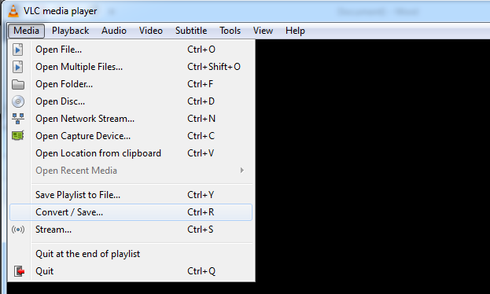

Next, add a video file you would like to convert and press Convert/Save…

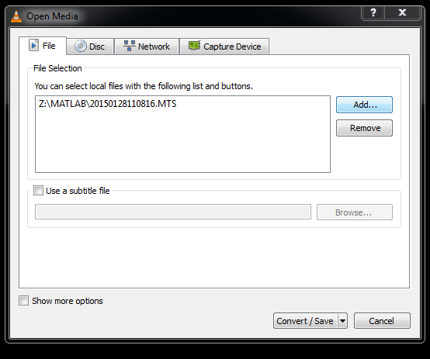

Then, select Video – H.264 + MP3 (MP4) for the convert profile, browse for where you want to save the file, and then press Start to convert the file…

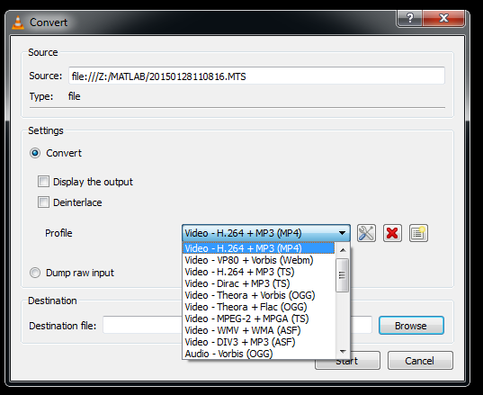

These steps must be repeated for each video file you would like to convert from .MTS to .MP4

**Operational Procedure:**

1. Open the GUI by running rocket_tracker_gui in the MATLAB command window. You will be prompted to select the .mp4 file of your video.
2. You should see the following GUI pop up:

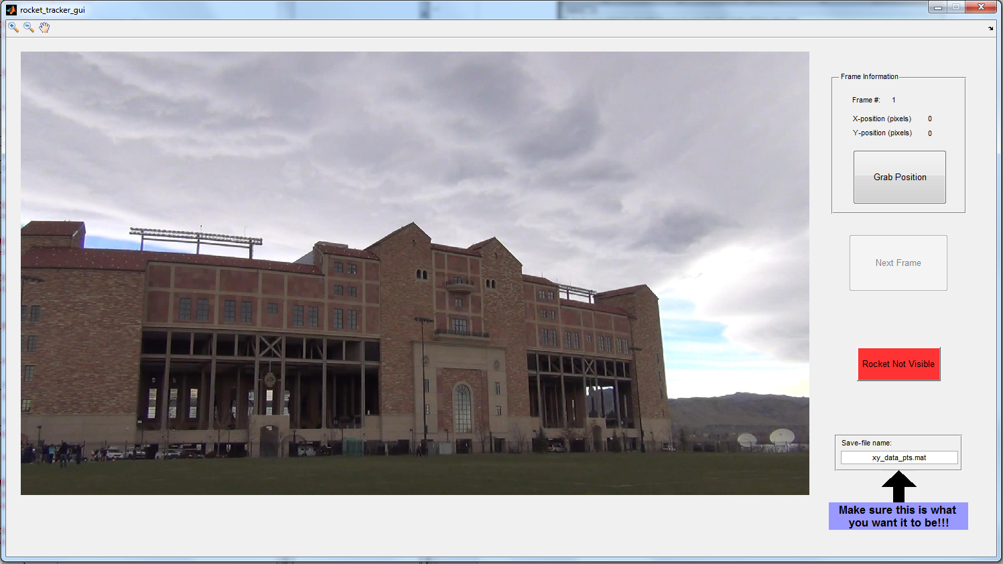

The first step you should do is change the save-file name field to the desired name. The GUI is designed to create the file if it does not already exist or to simply concatenate data points onto the file. **This means that you** **should use a different file name for different launches.** This field will be disabled after the first frame is processed.

1. Zoom in on the image (using the tools in the top-left of the GUI) to a point where you can tell where the rocket is, then press the “Grab Position” button. Then click on the position of the rocket within the image using the mouse. If your selection is not satisfactory, you can press the “Grab Position” button again to re-do the current frame’s position.

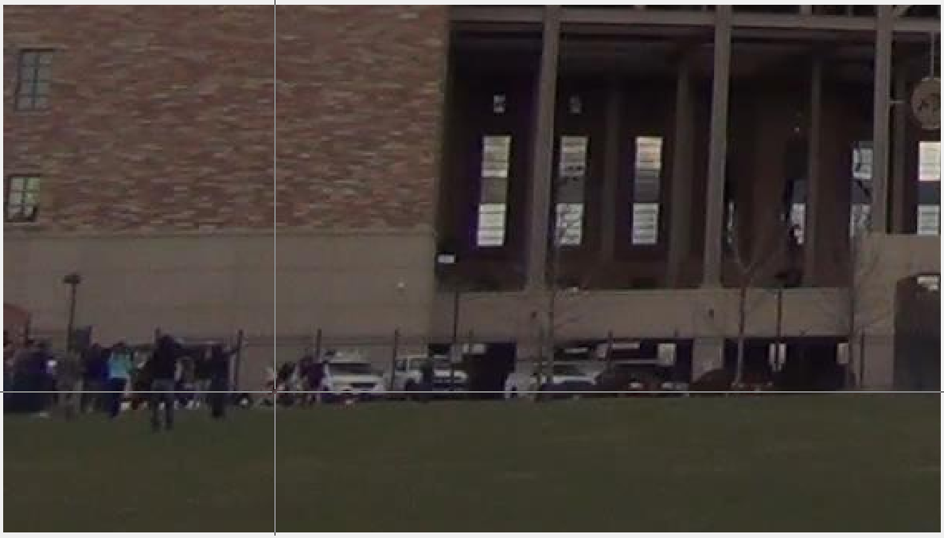

1. The “Next Frame” button will now be enabled and you can move on to the next frame by clicking it. Clicking this button saves the x- and y-positions of the rocket for the current frame.

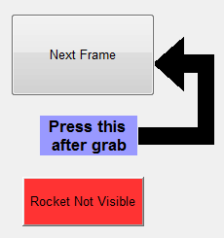

1. If you cannot detect the location of the rocket within the image, you can press the “Rocket Not Visible” button in order to skip the current frame without saving a position.
2. Continue this procedure until the GUI informs you that you have reached the end of the video.
3. You can now load your x- and y-positions of the rocket (in pixels) by using the MATLAB ‘load(‘ function on the .mat file that was created.

Use plot(data.x,1080-data.y,’.’)in order to view your rocket’s trajectory in pixels

1. By zooming in on an individual frame (see the MATLAB functions ‘VideoReader’, ‘read’ and ‘imshow’) you can determine the length of the reference height pole in pixels. Next, divide the known height of the pole in feet by this height in pixels to get a conversion factor for the vertical position of the rocket.
2. A similar conversion factor for horizontal position of the rocket can be found using the known horizontal distance traveled and the horizontal distance traveled in pixels.

Use plot(k_horiz.*data.x,k_vert.*(1080-data.y),’.’) in order to view your rocket’s trajectory in feet.